**Advanced Lead Filters Module of Perfex CRM Upgrade**

**Author : Sejal Infotech**

**Description:**

**SI Lead Filters** allows you to create dynamic filters for Leads in Perfex CRM, This can be used to generate different kind of reporting for your use.

This module is user friendly, quick and easy to install and use.

You can create filters and save them, by your given name, as filter Templates, to use them in future.

This module saves time of user in generating different reports from Lead filter because, Once filter is saved as Template, then that template can be used any time, in future.

Only allowed Staff members can use this Module.

**Steps to Upgrade:**

**Step 1. Upgrade Files:**

You have two options to upgrade Module files.

**Option 1:**

You will get si_lead_filters.zip file in All files Directory. You can use this zip file to Install this module in Perfex CRM. Just like you are Installing New Module.

Go to Perfex CRM->SETUP-> Modules.

Upload Module zip file and click Install button.

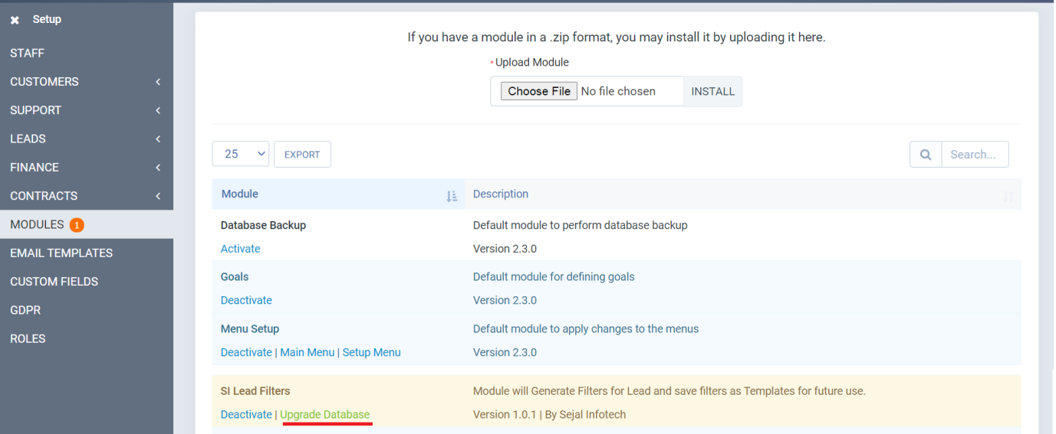

You will be able to see 'SI Lead Filters' Module in list of Modules and Upgrade Database link. So Files are upgraded.

Option 2:

If you do not want to Install that zip file again in Upgrade, then you can unzip that file in **PERFEX_CRM_PATH/modules/** directory where si_lead_filters directory is there. You can replace this directory by unzip folder.

**Step 2. Upgrade Database:**

After Upgrading files, you will see "Upgrade Database" link in SETUP-> Modules->SI Lead Filters.

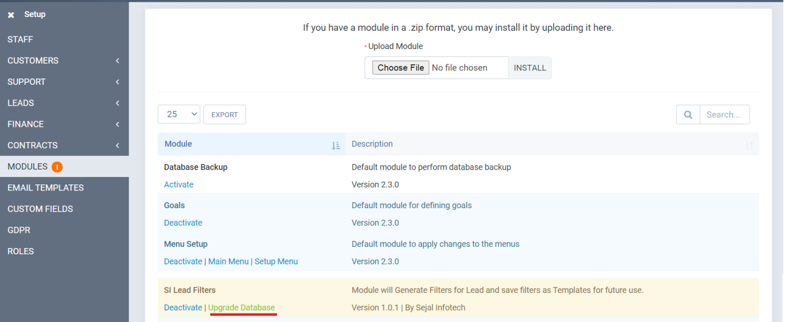

Click on that Link and Database will be Upgraded.

That's it....